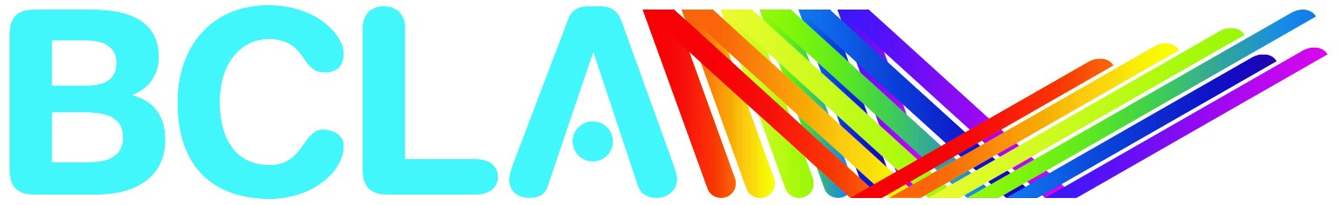

BCLA 2021 Dry Eye Practitioner of the Year Award Nomination Form

Name of nominee/team
Email
Telephone number
Please discuss how you meet the nomination criteria (1,000 words maximum)
(Please attach a separate page, if required)
Nominator name
Date

Please return the nomination form by 3 May 2021, together with 3 case records and any additional pertinent information such as testimonials to membership@bcla.org.uk

